LAB EXPERIMENT RECORD
Experiment 3: Employee Performance Analysis
Department | AIML
Course Code / Course Name | DSA0601 / Data Handling and Visualization
Experiment | Data Visualization using R and Tableau
Name | G. GANGA CHANDRIKA
Register Number | 1925260144
Date | 29 September 2026
Day | Tuesday

Aim
To visualize employee and sales data using a line chart, bar chart and scatter plot in R, to analyse the correlation between years of service and performance score, and to build an interactive dashboard in Tableau.
Datasets
Dataset 1: Monthly Sales
Month | Sales ($)
January | 15000
February | 18000
March | 22000
April | 20000
May | 23000

Dataset 2: Employee Performance
Employee ID | Department | Years of Service | Performance Score
1 | Sales | 5 | 85
2 | HR | 3 | 92
3 | Marketing | 7 | 78
4 | Sales | 4 | 90
5 | HR | 2 | 76

PROGRAM 1: Line Chart with Legend and Labels
Create a line chart to visualize the trend over time. Include a legend and labels.
# Dataset
monthly <- data.frame(
Month = c("January","February","March","April","May"),
Sales = c(15000, 18000, 22000, 20000, 23000)
)

# Line Chart
plot(monthly$Sales,
type = "o",
xaxt = "n",
main = "Monthly Sales Trend",
xlab = "Month",
ylab = "Sales ($)",
col = "blue",
pch = 19)

axis(1, at = 1:5, labels = monthly$Month)

# Legend
legend("topleft", legend = "Monthly Sales",
col = "blue", lty = 1, pch = 19)
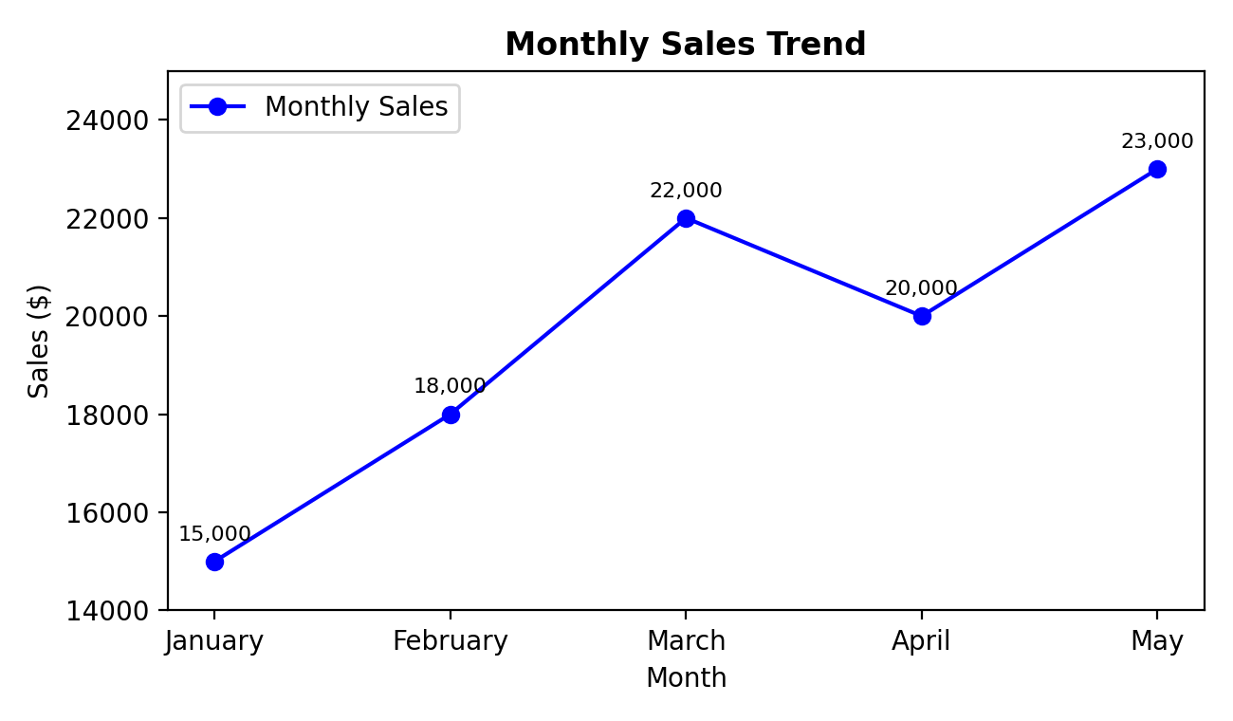
Output 1: Monthly Sales Trend Line Chart
Observation: Sales rise from $15,000 in January to $22,000 in March, dip to $20,000 in April, and reach the peak of $23,000 in May. The overall trend is upward. Because the employee dataset has no time column, the time-based trend is shown using the monthly data.
PROGRAM 2: Bar Chart of Employees by Department
Generate a bar chart showing the distribution of employees across departments. Label the chart elements.
# Dataset
employee <- data.frame(
EmployeeID = 1:5,
Department = c("Sales","HR","Marketing","Sales","HR"),
Years = c(5, 3, 7, 4, 2),
Performance = c(85, 92, 78, 90, 76)
)

# Count employees per department
department_count <- table(employee$Department)

# Bar Chart
barplot(department_count,
main = "Employees by Department",
xlab = "Department",
ylab = "Number of Employees",
col = "lightblue")
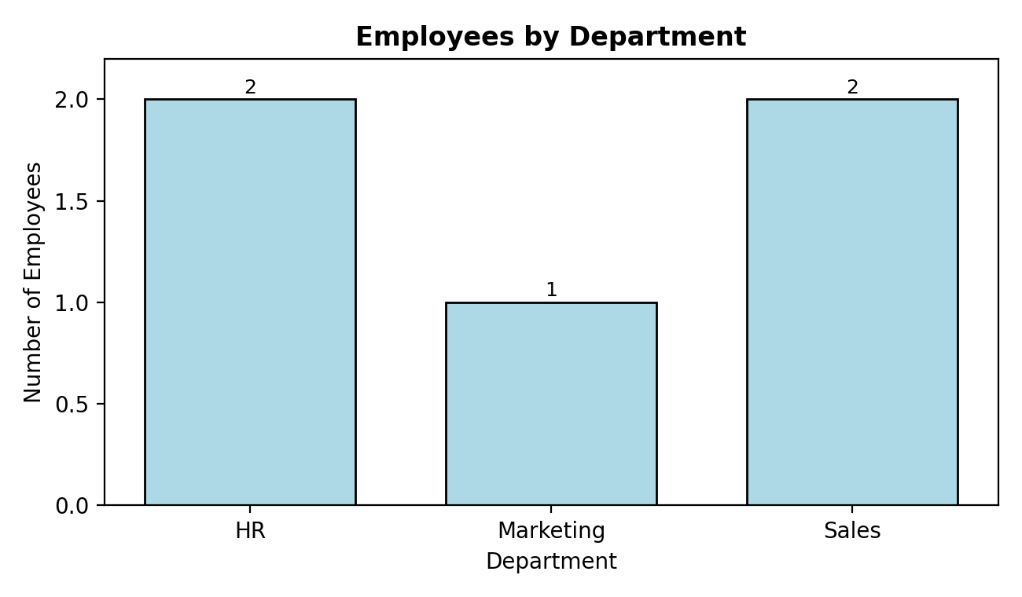
Output 2: Employees by Department
Observation: HR and Sales each have 2 employees, while Marketing has 1 employee. Employees are spread fairly evenly across the three departments.
PROGRAM 3: Scatter Plot of Years of Service vs Performance Score
Build a scatter plot to analyse the correlation between years of service and performance scores, and explain the insights.
# Scatter Plot
plot(employee$Years,
employee$Performance,
main = "Years of Service vs Performance Score",
xlab = "Years of Service",
ylab = "Performance Score",
pch = 19)

# Regression line
abline(lm(Performance ~ Years, data = employee),
col = "red", lwd = 2)

# Correlation coefficient
cor(employee$Years, employee$Performance)
# [1] -0.1687622
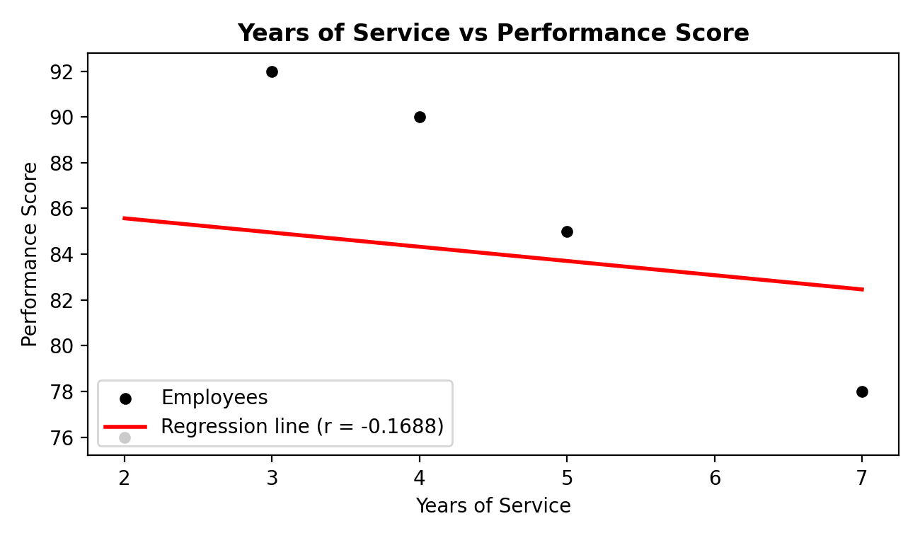
Output 3: Years of Service vs Performance Score
Insights:
- The correlation coefficient is r = -0.1688, a very weak negative correlation. The regression line slopes slightly downward (about -0.62 points per extra year).
- R² is about 0.028, so years of service explains only about 3% of the variation in performance scores.
- The points are widely scattered: the top scorers have 3 years (92) and 4 years (90) of service, while the employee with the most experience (7 years) scored 78 and the newest (2 years) scored 76.
- Longer service does not guarantee better performance, and other factors such as skills, role and training likely matter more.
- With only 5 employees the result is not statistically reliable; a larger dataset is needed before drawing firm conclusions.
PROGRAM 4: Interactive Tableau Dashboard
Develop a Tableau dashboard combining the line chart and bar chart for interactive exploration.
Steps in Tableau:
- Open Tableau and connect to Microsoft Excel, then select the file "employee data.xlsx". Add the sheets Monthly sales and Employee Performance.
- Sheet 1 (Line chart): drag Month to Columns and Sales to Rows (SUM). Set the mark type to Line, add Circle markers, drag Measure Names to Color to show the legend, and show mark labels. Rename the sheet "Sales Trend".
- Sheet 2 (Bar chart): drag Department to Columns and Employee ID to Rows (change to Count). Set the mark type to Bar, show mark labels, and add axis titles. Rename the sheet "Employees by Department".
- Create a new Dashboard. Drag "Sales Trend" and "Employees by Department" onto the canvas and give the dashboard a title.
- Add interactivity: click the Use as Filter icon on the bar chart, add a Highlight action (Dashboard > Actions), enable tooltips, and add a Department filter shown as a dropdown.
- Save the workbook or publish it to Tableau Public and test the interaction by clicking on a bar or a point.
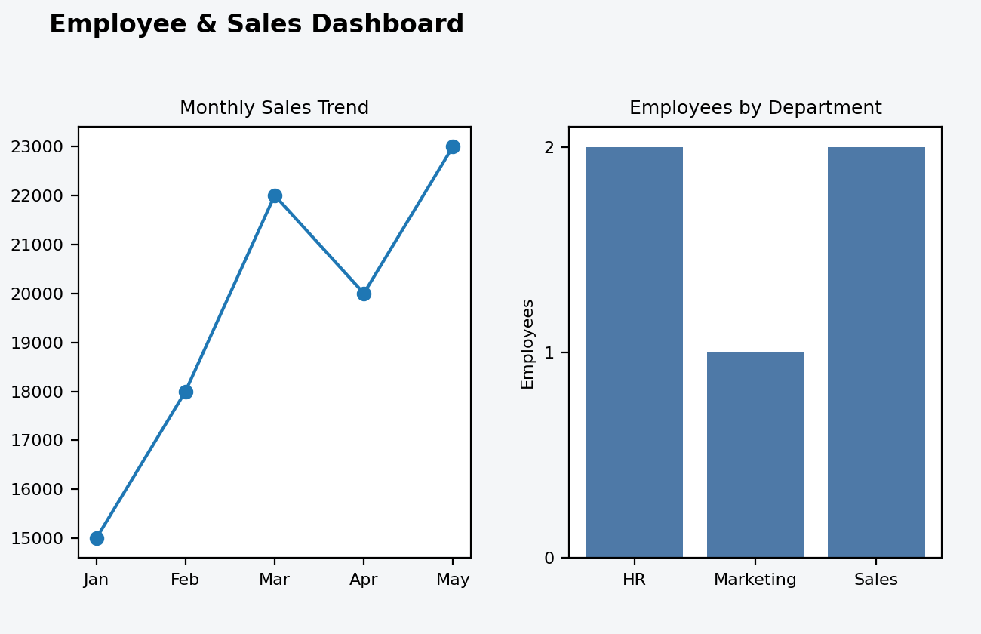
Output 4: Dashboard layout with Line Chart and Bar Chart
Observation: The dashboard places the sales trend line chart and the department bar chart side by side. Selecting a department or a month filters and highlights the related view, allowing interactive exploration of the data.
Result
The sales and employee data were visualized using a line chart, a bar chart and a scatter plot in R. The correlation between years of service and performance score was found to be weak and negative (r = -0.1688). An interactive dashboard combining the line and bar charts was designed in Tableau.
Key Functions Used
Function | Purpose
plot() | Creates line and scatter plots.
axis() | Adds custom axis labels.
legend() | Adds a legend to a plot.
table() | Counts employees per department.
barplot() | Creates the bar chart.
lm() / abline() | Fits and draws the regression line.
cor() | Calculates the correlation coefficient.

